
Studio Purity on Stage: Sam Smith Embraces the High Fidelity Performance of Sennheiser Spectera
Innovative Wideband Bidirectional Wireless Technology Delivers Premium Audio and Unmatched Spectral Efficiency for High-Profile Residencies in New York and San Francisco

San Francisco, April 7, 2026 — As Sam Smith enamored audiences during recent high-profile residencies at the Warsaw in Brooklyn and the re-launch of The Castro Theatre in San Francisco, the production’s technical team faced the task of managing complex wireless monitoring in congested RF environments. In response to this challenge, Sam Smith’s long-term monitor engineer, Saul Skoutarides, switched Sam and their band to Sennheiser’s Spectera — the world’s first wideband bidirectional digital wireless system. The move has redefined the production’s workflow, replacing the technical limitations of analog systems with a level of clarity that Skoutarides describes as "proper stereo."

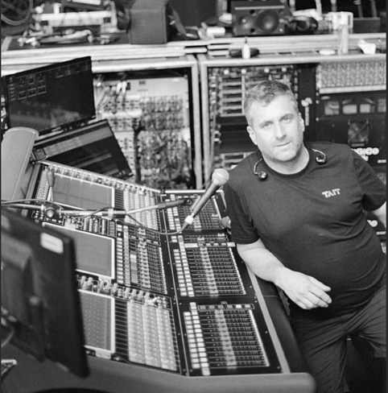 | Monitor Engineer Saul Skoutarides behind the mixing console.

Saul describes his career as a "long and exciting journey" that began in the Australian club scene in the mid 90’s, which has culminated in becoming a mainstay in the Sam Smith team. Skoutarides is intimately familiar with the constraints of legacy wireless gear. The switch to Spectera was driven by a need for increased reliability and a desire for a more musical, transparent monitoring experience. "FM stereo was invented in the '60s and up until now we’ve been using a version of it that isn’t that far away from the original," Skoutarides remarked. "It’s 'faux stereo' compared to what Spectera is doing. There’s no compander and comparatively no noise floor. Out of everything I’ve ever used, Spectera is the closest thing to plugging a pair of headphones straight into a nice headphone amp."


Each musician in Smith’s band is supported by Spectera’s consistent wireless audio and flexible in-ear monitoring.

The difference was particularly apparent in the low-end frequency response. Skoutarides noted that in the past, low frequency synth-bass or sub-patches could make traditional RF go "squiffy" because of how the compander reacts to those frequencies. With Spectera, that fluttering simply doesn't exist. "The low end is real," Skoutarides explained. "When I A/B tested it against the 2000 series, the legacy gear suddenly sounded like the low end was out of phase. I was more than sold!"
Beyond the technical specs, the elimination of the constant background hiss inherent in older analog technology led to a marked change in the energy of the room during long rehearsal days. The Musical Director, David Odlum, a top-tier producer and studio engineer, noticed the difference on day one. "These make zero noise," Skoutarides recounted. "We realized we weren't hitting that wall of fatigue. That constant RF noise floor eats away at your brain subconsciously. Removing that completely changed the energy in the room. Even our performers, some of whom are skeptical of in-ears were blown away by the clarity."


Sam Smith and band perform live using Sennheiser Spectera, the world’s first wideband bidirectional wireless system.

In the dense urban landscape of Brooklyn, Spectera’s ability to operate amidst heavy interference proved essential. Unlike traditional systems that require a perfectly clear frequency for every individual channel, Spectera’s wideband approach allowed Skoutarides to operate effectively even in occupied spectrum. "At gig time in New York City, unknown elements out of our control pop up all over the place," Skoutarides noted. "I was operating with low-to-mid-level interference on those TV channels, and it didn't make any difference. It worked fine. There was no stress knowing it will work in an environment with such a high noise floor."

The system’s bidirectional control also solved logistical headaches involving remote dressing rooms and high-pressure changeovers. Skoutarides recalled a festival in Mexico where he had to manage the RF deployment solo. ”I recently had a situation where I needed to change one frequency block last minute. Previously, I would have had to run to the dressing room and collect all the packs before making an alternative RF plan and deployment in the middle of a festival changeover, which can be extremely stressful. Now, with Spectera, the pack will stay silent until it sees the base station. I watched the packs walk into range and re-sync automatically as the band walked toward the stage, which was a real weight off my shoulders in that situation."

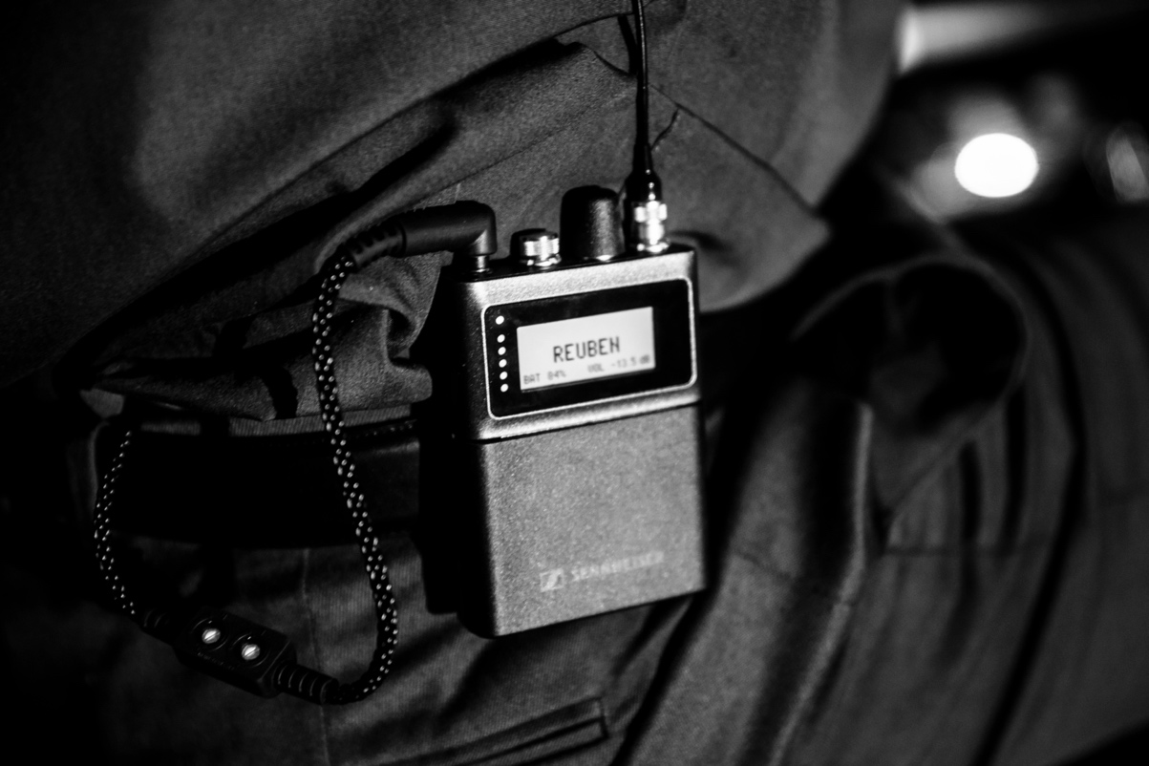
The Spectera bodypack combines microphone transmission and in-ear monitoring in a single bidirectional device, reducing set-up time and streamlining operations.

From a physical perspective, the shift from rigid LMR400 RF cabling to standard Cat 5 has streamlined the tour's infrastructure, replacing cumbersome, breakable cables with a setup that "stagehands can’t destroy as easily." By utilizing MADI integration and ultra-low latency modes, the production achieved a level of fidelity that handles Smith’s complex vocal reverbs and high-fidelity arrangements with ease.

For Skoutarides, the shift represents more than just a gear upgrade; it is a permanent change in philosophy. "I’ve spent my career climbing toward better quality sound, and this is the next level. We’ve found the silence, and we’ve found the space. I’m never going back."

Sam, band and production team behind the scenes of his recent residencies.

As Sam Smith prepares for future tour dates, Skoutarides is looking forward to continuing the production’s journey with Spectera. “Once the [SKM] handheld transmitters are available, they’ll be a natural addition, when we need to use a wireless mic again” he said. “It will give Sam the freedom needed on stage while delivering that same very high-quality audio experience to the audience.”
The Spectera SKM Handheld Transmitter is available for preorder and expected to begin shipping in September 2026. For more information about Sennheiser and its solutions, visit www.sennheiser.com.

###

About the Sennheiser brand
We live and breathe audio. We are driven by the passion to create audio solutions that make a difference. Building the future of audio and bringing remarkable sound experiences to our customers – this is what the Sennheiser brand has represented for more than 75 years. While professional audio solutions such as microphones, meeting solutions, streaming technologies and monitoring systems are part of the business of Sennheiser electronic GmbH & Co. KG, the business with consumer devices such as headphones, soundbars and speech-enhanced hearables is operated by Sonova Holding AG under the license of Sennheiser.

www.sennheiser.com
www.sennheiser-hearing.com

Local Press Contacts
InGear
Chloe Hildeman
chloe@ingearpr.com
+1 425-466-2264

Global Press Contact
Daniella Kohan
daniella.kohan@sennheiser.com
+1 (860) 227-2235

